**ARCHITECT AND BUILD END TO END WEB APPLICATION**

**Services used**

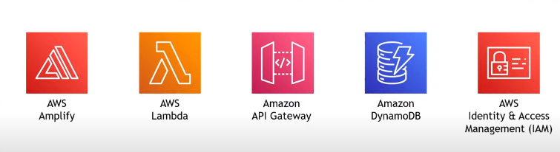

**Architecture**

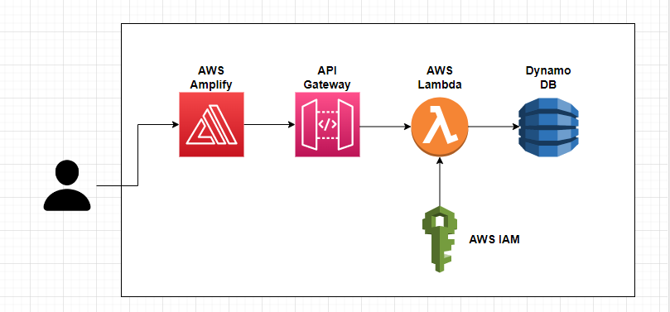

**Steps to be done**

1. Create a web/host page
2. Invoke the math functionality
3. Do the math calculation
4. Store/Return the result

**STEPS**

**1. Creating a Web Page using AWS Amplify**

**AWS Amplify:** Used to build and host the websites

AWS Amplify is a set of products and tools that enable mobile and front-end web developers to build and deploy secure, scalable full-stack applications, powered by AWS.

Open amplify in AWS console 🡪 New app 🡪 Host your web app 🡪 Deploy without Git provider 🡪Give the app name ---- Drag and drop the zip of index.html file 🡪 Save and deploy

Use the domain link to see the result

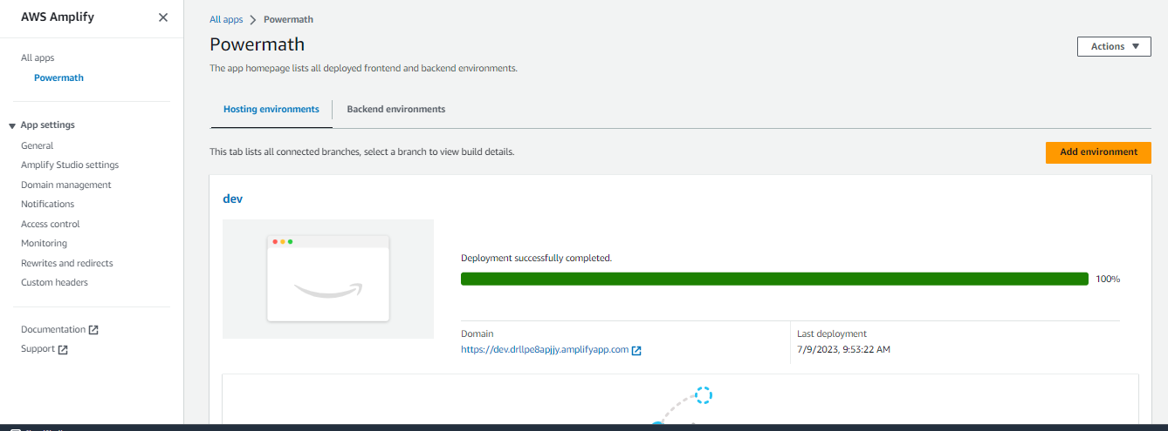

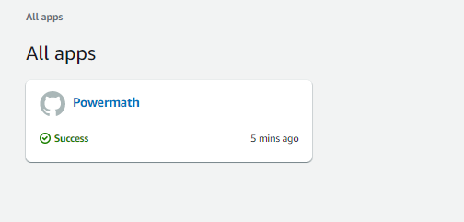

**2. Creating a Math Functionality using AWS Lambda**

**AWS Lambda:** Code that runs (serverlessly) upon some trigger

Open AWS lambda in AWS console 🡪 Create function 🡪 Author from scratch 🡪 Select Python 3.10 in Runtime 🡪 Create function

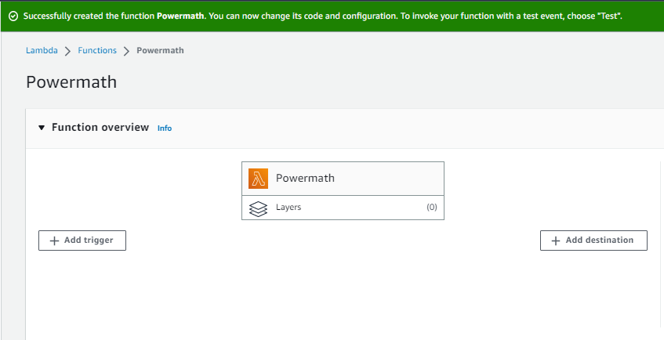

Copy the python code 🡪 Save (ctrl +S) 🡪 deploy 🡪 Test drop down menu (Configure test event) 🡪 Give the event name ---- In event JSON give the Base and event value ---- Save 🡪 Test

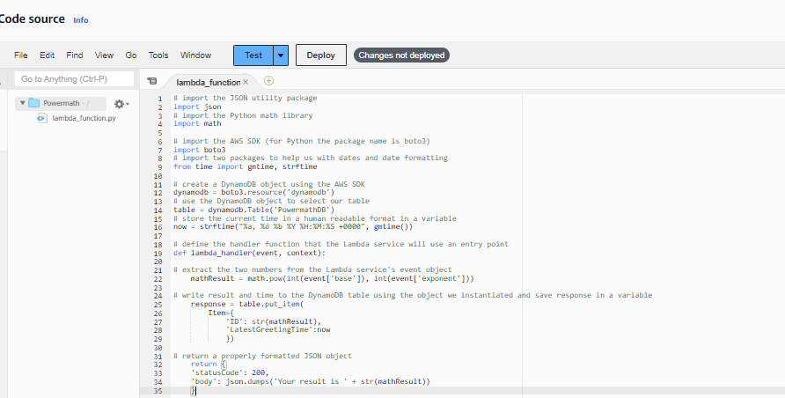

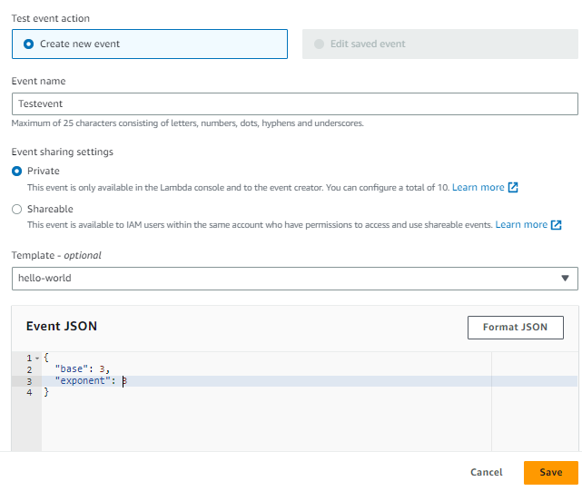

**3. Invoking the Math functionality using API Gateway**

**API Gateway:** Used to build HTTP, REST and WebSocket API’s

Open API Gateway in AWS console 🡪 Create API 🡪 Build Rest API 🡪 Under Choose protocol select **Rest** 🡪 Under create new API select **New API**  🡪 Create API

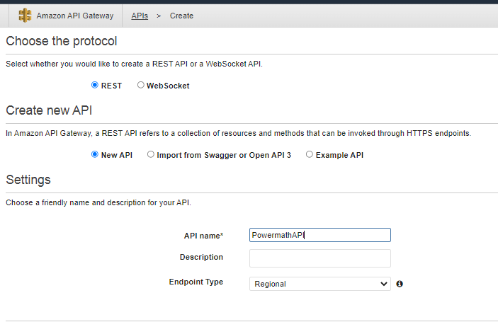

Select resources in side menu 🡪 Select “/” 🡪 Actions 🡪 Create method 🡪 Type of method as **POST**  🡪 Select the “Right symbol” (Its near POST) 🡪 Under Integration type select Lambda Function ----- Under Lambda function select the Lambda function which has to be invoked 🡪 Save

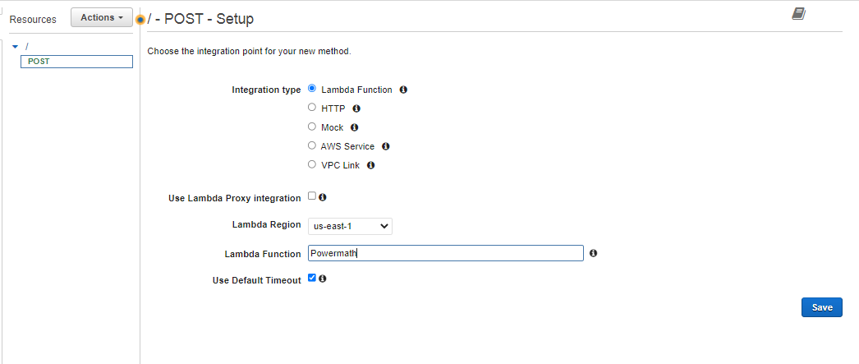

Select Post 🡪 Actions 🡪 Enable CORS 🡪 Enable CORS and replace existing CORS headers

CORS --- Cross origin Resource Sharing

By enabling this, this allows the web application running in one origin or domain to be able to access resources on a different origin or domain.

Our application is running on AWS Amplify domain and Lambda function is running in another domain, we need to be able to work across those domains.

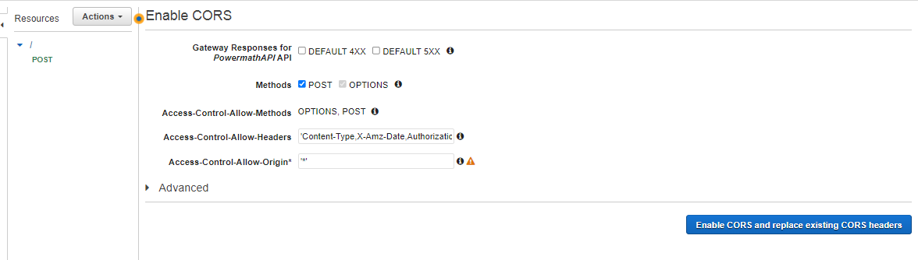

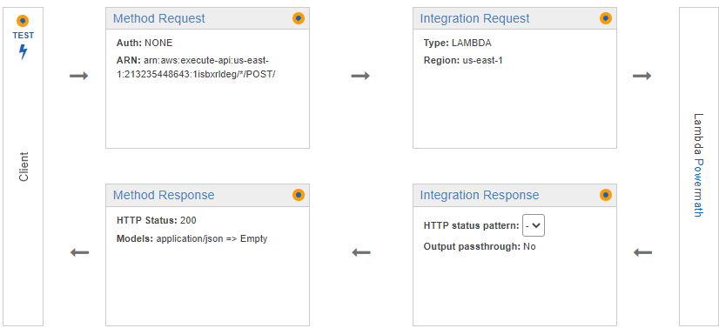

Select POST 🡪 Actions 🡪 Deploy API 🡪 Select Deployment stage and give Deployment Name 🡪 Deploy 🡪 Copy and Keep the **invoke URL** for future use

Select Resources in side menu 🡪 POST 🡪 Click on lightning symbol below the TEST 🡪 In request body give the base and exponent values 🡪 TEST

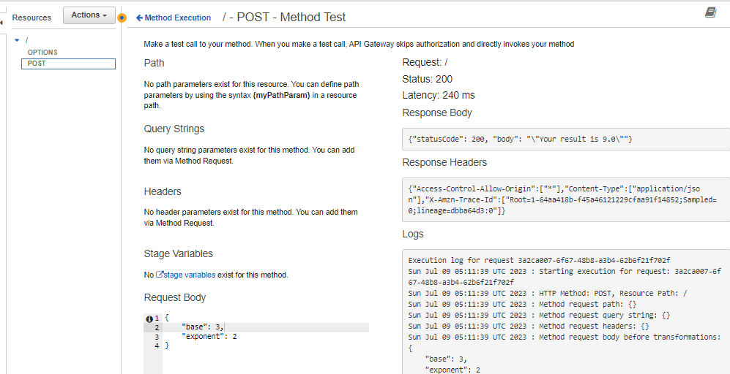

**5. Storing the Results in the DynamoDb table**

**Dynamo DB:** Used to store the results

Open Dynamo DB in AWS console 🡪 Create a Table 🡪 Give Name and type ID in partition key 🡪 Create table

Copy the ARN number of DynamoDB created and keep it safe for future use

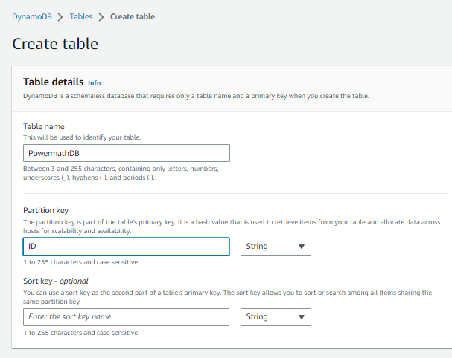

**5. Giving permissions to AWS Lambda to edit in Dynamo DB table**

Create a role in IAM so that Lambda function gets the permission to edit the table dynamo DB

Open Powermath function in Lambda which is created earlier 🡪 Configuration 🡪 Permission 🡪 Select the Powermath-Role 🡪 IAM console opens in new Tab 🡪 Add permissions 🡪 Create inline policy 🡪 JSON 🡪 Paste the Policy 🡪 Paste the ARN of the Dynamo DB 🡪 Next 🡪 Give the policy name 🡪 Create policy

Open the html code and Update the API gateway invoke URL here and create a zipo file drag and drop inside the APP created in AWS Amplify

.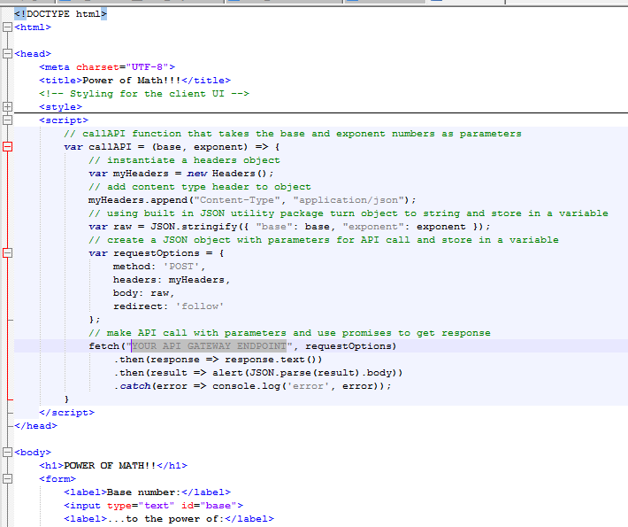

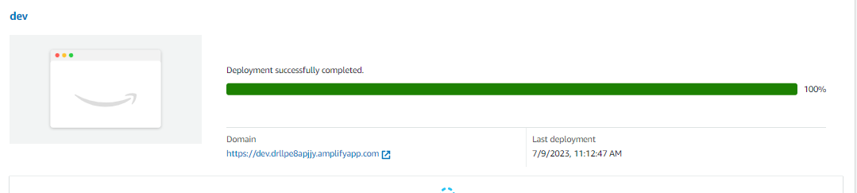

**Results**

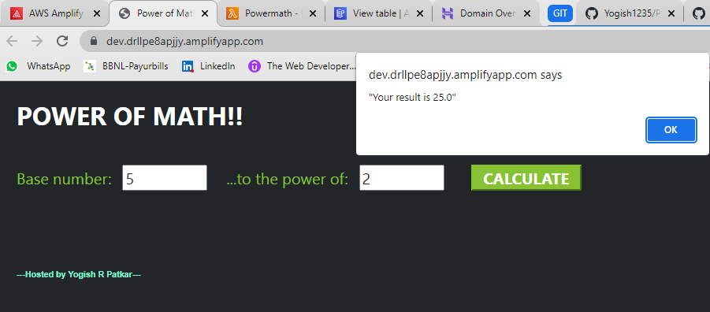

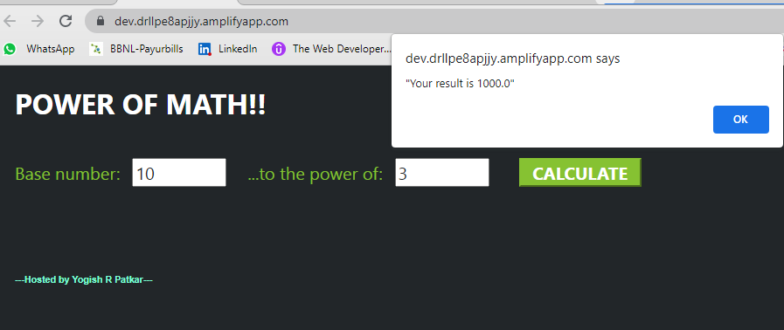

**Results updated in table**

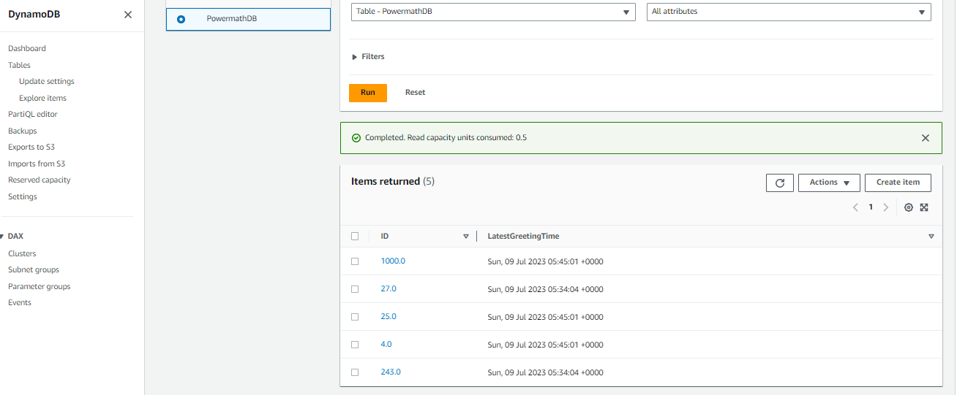

**Reference**

https://youtu.be/7m_q1ldzw0U